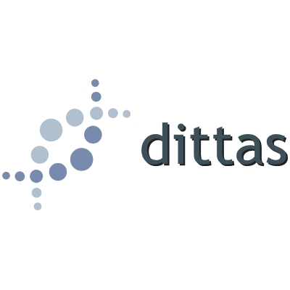
Do you need help or advice with your 2019/2020
Exam Access Arrangements?

Sarah Beard is an experienced SpLD Specialist who is qualified to assess for Exam Access Arrangements. The rates are exceptionally reasonable and we offer a flexible package of services as detailed below:
Gold package ***BEST VALUE***
This package includes group testing at the start of the school day, then individual 1:1 testing until the end of the school day. A member of staff must be available to collect the children from their classes as needed. Sarah is usually able to get through around 15 children using this method.
Testing can vary but core testing includes: DASH for handwriting speed/scribe; WIAT2T Spelling for scribe; WIAT3T Single Word Reading for reader; CTOPP2 Rapid Naming for processing speed. Additional tests, if required, include LUCID Comprehension and TOMAL Working Memory. Testing takes between 10 and 30 minutes per child.
This is charged at £495 per 10 students which includes completion of Form 8 Part C . If additional children are seen during the day these are each charged at £45 each 2. The Form 8 Part C’s are processed off site and returned within seven working days.
Bronze package
For groups of less than 10 students the fee is £75 per head 2. Form 8s can be processed on the day and included in the fee. An additional fee will be charged for travel if the school is more than 30 minutes from BR6.
Bespoke package
If you only want reading testing or handwriting this can be arranged at a heavily reduced price. Please contact us with your requirements.
Hourly rate
If you have a number of children but are unable to arrange for group testing at the start of the day or want the Form 8 Part C’s completed on the day we can offer an hourly or day rate – please contact us to discuss your requirements.
Regulations update
If you chose the gold package, Sarah can provide a 45 minute training session on the updated EAA regulations free of charge. If other packages are chosen you can add this training for £55. On site update training for those not requiring testing is available from £150. CONTACT SARAH TO DISCUSS YOUR NEEDS OR TO BOOK TESTING 01689 862610 or info@dyslexiaservices.net

All assessors hold AMBDA and APC Status.
A small additional charge is made for the test papers that are used.
We hold current DBS and are registered as a data controller under the Data Protection Act 1998 (DPA) Registration Reference: Z3451398 (Dittas Limited). We take GDPR seriously.

