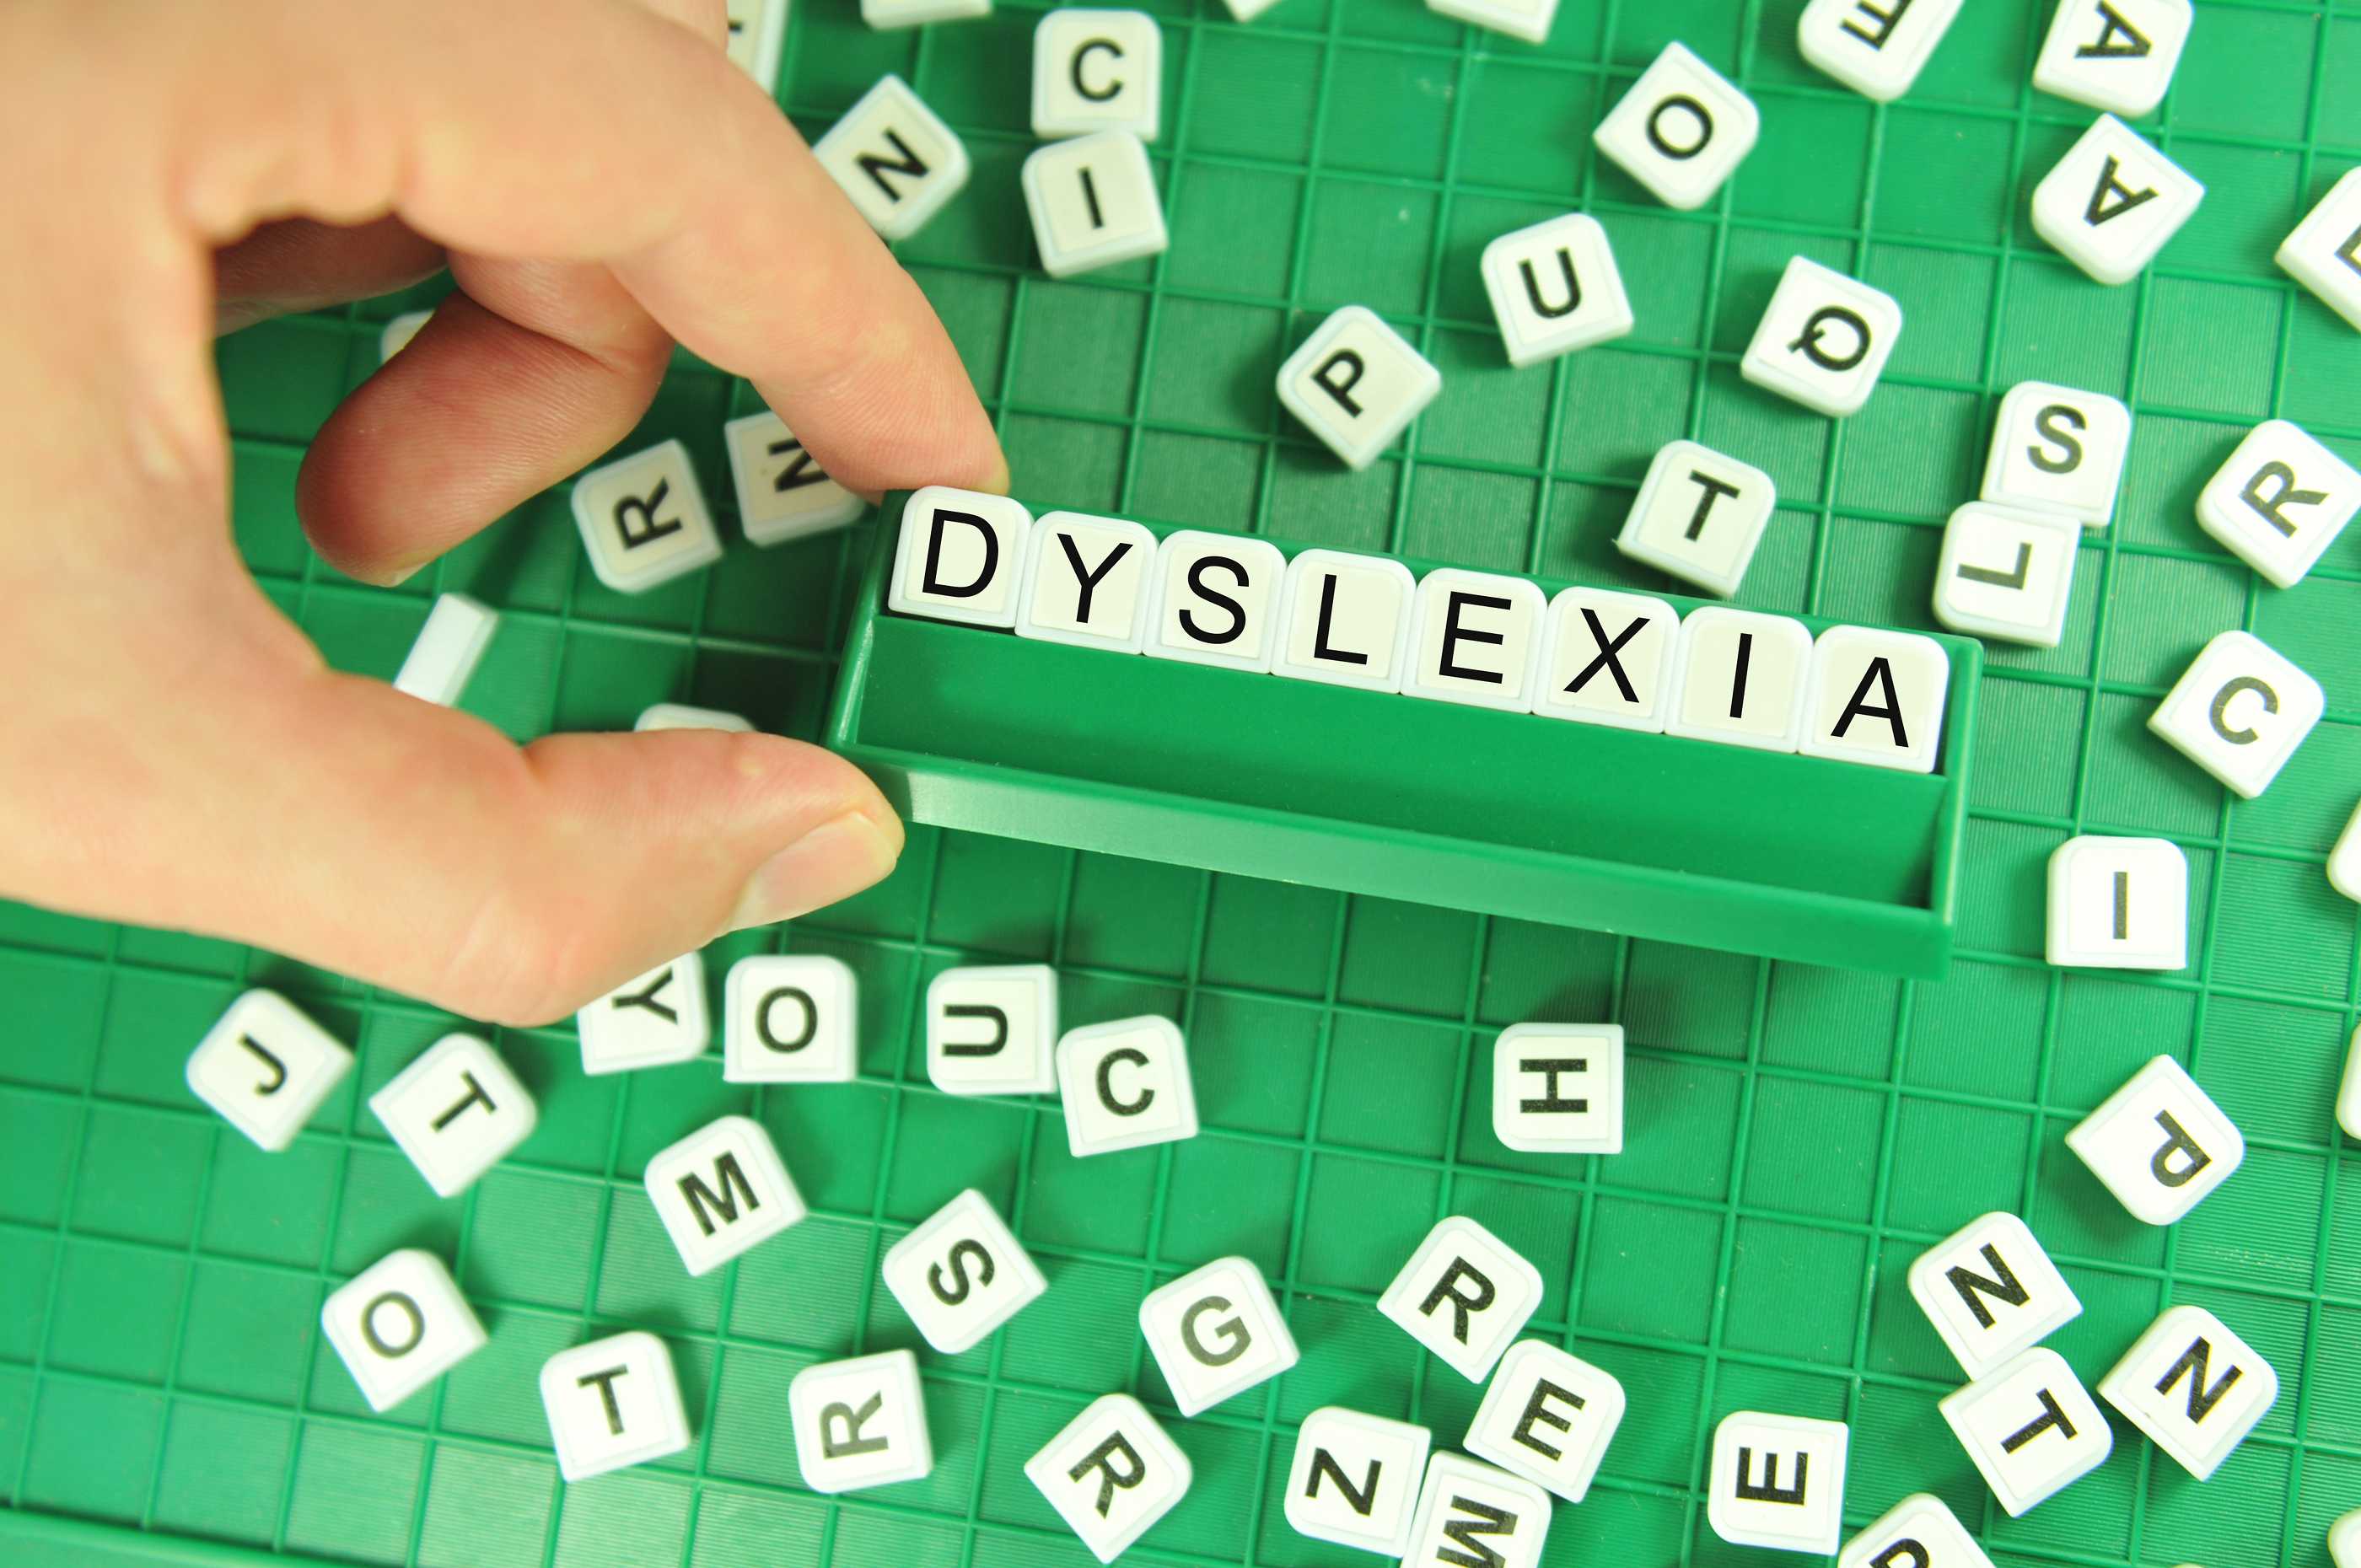

A consultation gives the opportunity to ask questions and think through the options for your child

## Sarah Beard, Director of Dyslexia Services can provide advice on dyslexia support and tuition, assessment options, ways to support you child at home and school, interpretation of reports and school selection.

# Need advice and help?

First 15 minutes free, further fee £50 per hour

Available by Skype or in person at our office in Orpington, Kent

Dyslexia Advice and Consultancy Service